**Information paradox simplified**

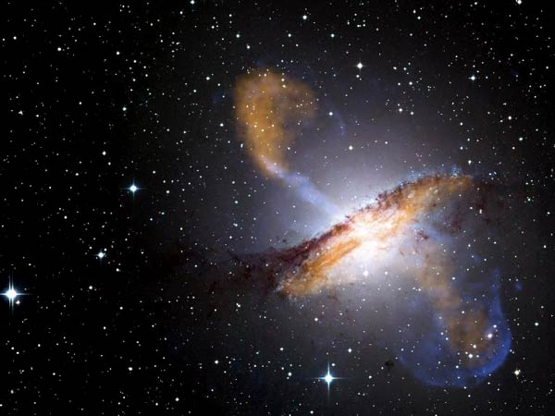

This Chandra X-ray Observatory image of Centaurus A shows a view of the jets and lobes powered by a supermassive central black hole in this nearby galaxy. The data show that material in the jet is travelling at about half the speed of light. (Courtesy: X-ray: NASA/CXC/CfA/R.Kraft et al.; Submillimeter: MPIfR/ESO/APEX/A.Weiss et al.; Optical: ESO/WFI)

A black hole’s event horizon is the ultimate last-chance saloon: beyond this boundary nothing, not even light, can escape. But does this “anything” include information itself? Physicists have spent the best part of four decades grappling with the “information paradox”, but now a group of researchers from the UK thinks it can offer a solution.

The researchers have created a theoretical model for the event horizon of a black hole that eschews space–time altogether. Their work also supports a controversial theory proposed last year that suggests that gravity is an emergent force rather than a universal fundamental interaction.

**Paradoxical history**

The information paradox first surfaced in the early 1970s when Stephen Hawking of Cambridge University, building on earlier work by Jacob Bekenstein at the Hebrew University of Jerusalem, suggested that black holes are not totally black. Hawking showed that particle–antiparticle pairs generated at the event horizon – the outer periphery of a black hole – would be separated. One particle would fall into the black hole while the other would escape, making the black hole a radiating body.

Hawking’s theory implied that, over time, a black hole would eventually evaporate away, leaving nothing. This presented a problem for quantum mechanics, which dictates that nothing, including information, can ever be lost. If black holes withheld information forever in their singularities, there would be a fundamental flaw with quantum mechanics.

The significance of the information paradox came to a head in 1997 when Hawking, together with Kip Thorne of the California Institute of Technology (Caltech) in the US, placed a bet with John Preskill, also of Caltech. At the time, Hawking and Thorne both believed that information was lost in black holes, while Preskill thought that it was impossible. Later, however, Hawking conceded the bet, saying he believed that information is returned – albeit in a disguised state.

At the turn of this century, Maulik Parikh of the University of Utrecht in the Netherlands, together with Frank Wilczek of the Institute of Advanced Study in Princeton, US, showed how information could leak away from a black hole. In their theory, information-carrying particles just within the event horizon could tunnel through the barrier, following the principles of quantum mechanics. But this solution, too, remained debatable.

### **Tunnelling through the event horizon**

Now, Samuel Braunstein and Manas Patra of the University of York in the UK think they have formulated a tunnelling theory that looks rather more attractive than Parikh and Wilczek’s theory. “We cannot claim to have proven that escape from a black hole is truly possible,” they explain, “but that is the most straightforward interpretation of our results.”

Normally, theorists dealing with black holes have to wrestle with the complex geometries of space–time arising from Einstein’s theory of gravitation – the theory of general relativity. In their model, Braunstein and Patra say that the event horizon is purely quantum mechanical in nature, with bits of quantum “Hilbert” space tunnelling through the barrier.

The theorists find that even such a heavily simplified tunnelling model can reconstruct the spectrum of radiation that is thought to emanate from black holes. This is unlike Hawking’s pair-creation model, which leads to the information loss and has always required many more theoretical details to work. Put simply, Braunstein and Patra say that tunnelling seems far more likely to be an intrinsic feature of black holes – so, probably, information is not lost after all. Their findings are published in the latest issue of Physical Review Letters.

### **Gravity’s depth**

There is yet another twist to the researchers’ work. Last year, string theorist Erik Verlinde of the University of Amsterdam, building on work by Ted Jacobsen of the University of Maryland in the US, put forward a speculative idea for the origin of gravity. Under Verlinde’s proposal, gravity is not a fundamental interaction, but emerges from the universe trying to maximize disorder. Gravity is therefore an “entropic force” – a natural consequence of thermodynamics – much as one feels a force on a stretched rubber band as the molecules attempt to squiggle up into disordered states.

Braunstein and Patra believe that their black-hole model goes in favour of Verlinde’s proposal. If gravity – not to mention inertia or space–time – is an emergent force, then it would not be utilized to unravel the basic information-loss mechanism of black holes, which is what the York researchers have shown. “This doesn’t prove that Verlinde is correct, but that his proposal ‘has legs’,” Braunstein tells *physicsworld.com*.

Steve Giddings, a physicist specializing in quantum gravity at the University of California, Santa Barbara, does not think that Braunstein and Patra have addressed “the most central questions” of Verlinde’s proposal. However, he says they have put forward another hint of an important link between quantum information and gravity. “An important challenge is to figure out whether the ideas enunciated by Verlinde and others can be given a more concrete foundation,” he adds. “This may be one more piece of that puzzle, but we’re not there yet.”